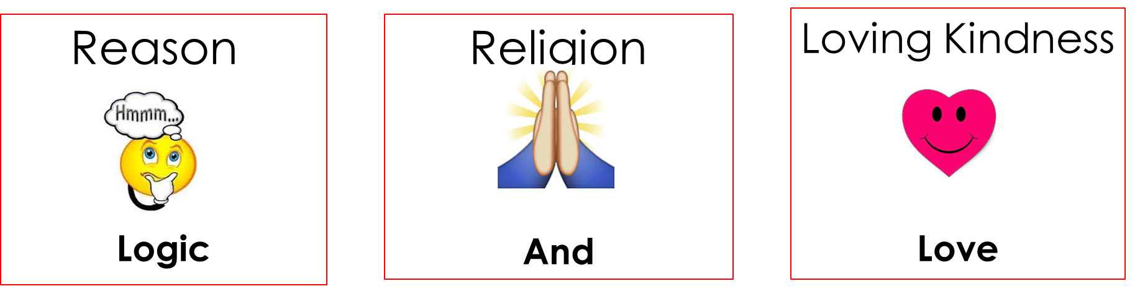

**The Power of Prayer**

The Power of Empathy!

Power of

Affordable Mistakes

* Kids desperately need __limits__.
* Kids learn to develop good decision-making skills by making small mistakes and experiencing the natural or logical outcome.
* Empathy allows us to hold our children firmly accountable without losing their love and respect .
* Empathy allows us to remain the “good guy” while allowing our child’s poor decision to be the “bad guy.”

__________________________________________________________________________________________

**Loving Kindness/Love**: The Power of Empathy 

The purpose of empathic statement is allowing the child to own the situation.

* Pick one memorize it, and apply it to setting limits or consequences. Examples are:
* That is never good.. - Ohhhhhh…
* Oh man,… - What a bummer
* Sorry it turned out that way… - This is so sad

After the empathetic statement, hand the problem back to the kid

**Religion**: The Power of Prayer

* Praying before each meal, grateful for the gifts He has given us.
* Pray for those who we personally know or see who are struggling.
  + Afterward discuss what we can do to help them.
* Teach them that praying doesn’t always resolve the situation the way we think it should. It allows us to know that God will be with us, no matter what happens.
* Sometimes what we go through is very difficult, and prayer allows us to know we do not need to carry the burden alone.
* Prayer allows us to talk to God, and let Him guide us to either BE or discover the solution.

****__________________________________________________________________________________________

**Reason/Logic**: Power of Affordable Mistakes 

small mistakes

Kids who are allowed to learn from__________________ early in life, are far less likely to make _________________ later on.

tragic mistakes

**Affordable vs. Unaffordable Mistakes: Circle one:**

Forgetting their lunch in the morning Affordable Unaffordable

Totaling their tricycle on the lawn Affordable Unaffordable

Totaling their car at 16 Affordable Unaffordable

Wasting allowance at age 13 Affordable Unaffordable

Wasting their bank account at age 33 Affordable Unaffordable

“Forgetting” to do their homework Affordable Unaffordable

“Forgetting” to complete a project at work Affordable Unaffordable

Eating too much candy and feeling sick Affordable Unaffordable

Gulping a gallon of vodka at a frat house Affordable Unaffordable

Playing video games for hours Affordable Unaffordable

Chatting with strangers online Affordable Unaffordable

Allow your kids to make affordable mistakes today, and let them learn the natural consequences to resolve the situation. Do NOT rescue them. They are smart, strong, and need the opportunity to fix it and learn.

Their mistakes are their “learning opportunities.”